Experiment 8
CREATE TABLE STUDENT1 (
sid INT PRIMARY KEY,
sname VARCHAR(50),
dept VARCHAR(50),
marks INT
);
set serveroutput on;
show serverout;
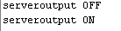
1:create or replace trigger Trg_check1_marks
before insert on STUDENT1
for each row
begin
if:NEW.marks<0 then
RAISE_APPLICATION_ERROR(-20001,'MARKS CANNOT BE NEGATIVE');
END IF;
END;
/
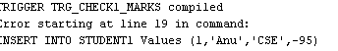
INSERT INTO STUDENT1 Values (1,'Anu','CSE',-95);
INSERT INTO STUDENT1 Values (2,'Ammu','CSE',95);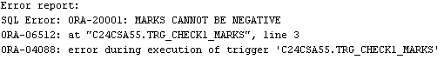
CREATE TABLE customer_details (cust_id NUMBER UNIQUE,cust_name VARCHAR2(30),address VARCHAR2(100));
INSERT INTO customer_details VALUES (101,'TOM ','Chennai');
INSERT INTO customer_details VALUES (102,'SAM','Mumbai');
INSERT INTO customer_details VALUES (103,'ELIZA','Kolkata');
select * from customer_details;
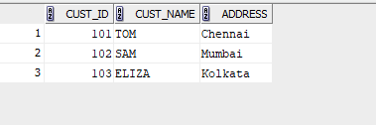
CREATE TABLE emp_details (empid NUMBER UNIQUE,empname VARCHAR2(30),salary NUMBER);
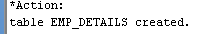
INSERT INTO emp_details VALUES (201,'RAM',18000);
INSERT INTO emp_details VALUES (202,'Priya',17000);
INSERT INTO emp_details VALUES (203,'Jack',19500);
select * from emp_details;
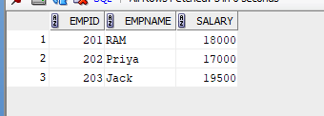
CREATE TABLE cust_count (count_row NUMBER);
INSERT INTO cust_count VALUES (0);
select * from cust_count;
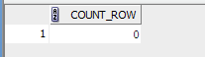
2:CREATE OR REPLACE TRIGGER trg_new_customer
AFTER INSERT ON customer_details
FOR EACH ROW
BEGIN
DBMS_OUTPUT.PUT_LINE('New customer record inserted successfully.');
END;
/
INSERT INTO customer_details VALUES (104,'Neha Reddy','Hyderabad');
INSERT INTO customer_details VALUES (108,'LIYA','Hyderabad');
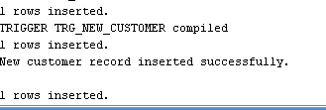
3:CREATE OR REPLACE TRIGGER trg_salary_check
BEFORE INSERT OR UPDATE ON emp_details
FOR EACH ROW
BEGIN
IF :NEW.salary > 20000 THEN
DBMS_OUTPUT.PUT_LINE('Warning: Salary greater than 20000 entered!');
END IF;
END;
UPDATE emp_details SET salary = 21000 WHERE empid = 202;
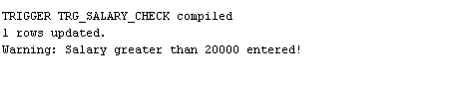

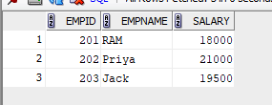
CREATE OR REPLACE TRIGGER trg_customer_count
AFTER INSERT OR DELETE ON customer_details
FOR EACH ROW
BEGIN
IF INSERTING THEN
UPDATE cust_count SET count_row = count_row + 1;
ELSIF DELETING THEN
UPDATE cust_count SET count_row = count_row - 1;
END IF;
END;
/
DELETE FROM customer_details WHERE cust_id = 101;
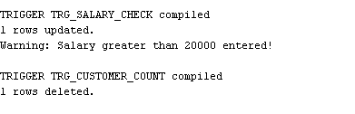
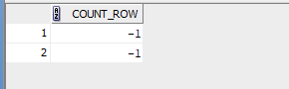

4:CREATE TABLE deleted_emp AS SELECT * FROM emp_details WHERE 1=0;
CREATE TABLE updated_emp AS SELECT * FROM emp_details WHERE 1=0;

CREATE OR REPLACE TRIGGER trg_emp_backup
AFTER DELETE OR UPDATE ON emp_details
FOR EACH ROW
BEGIN
IF DELETING THEN
INSERT INTO deleted_emp VALUES (:OLD.empid, :OLD.empname, :OLD.salary);
DBMS_OUTPUT.PUT_LINE('Deleted record moved to deleted_emp table.');
ELSIF UPDATING THEN
INSERT INTO updated_emp VALUES (:OLD.empid, :OLD.empname, :OLD.salary);
DBMS_OUTPUT.PUT_LINE('Old record stored in updated_emp table before update.');
END IF;
END;
/
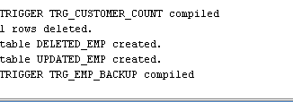
UPDATE emp_details SET salary = 25000 WHERE empid = 203;
DELETE FROM emp_details WHERE empid = 201;
